**Variable Regulated Power Supply: 1.2 to 30 Volts @ 1 Amps**

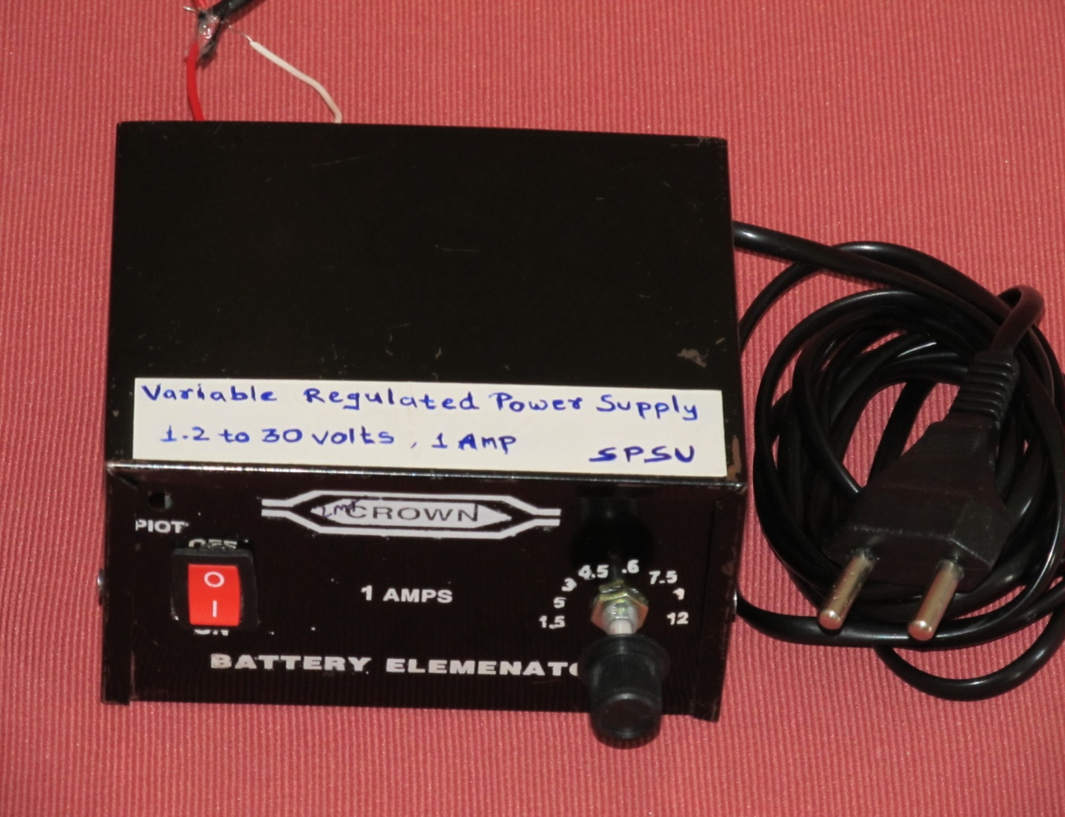

This project is a positive variable power supply that is compact and easy to build. It is ideal for powering any application requiring a DC supply at current levels up to 1A. This power supply project should be among the first project that all electronic hobbyists should embark on. With this power supply, one can use it to power up many electronic kits and projects instead of using batteries.

The features of this circuit are:

* LED power on indication
* Variable output voltage
* AC or DC input voltage
* Low noise

The circuit diagram of the variable regulated power supply is shown in figure-1.

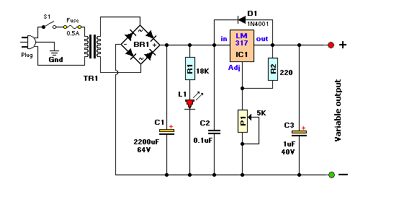

Figure-1: Circuit diagram of variable regulated power supply.

**Circuit Description:** The 230V-AC coming from the power cord is fed to the transformer TR1 via the on-off switch and the 500mA fuse. The 24v ac output (approximately) from the transformer is presented to the BR1, the bridge-rectifier, and here rectified from AC (Alternating Current) to DC (Direct Current). The pulsating DC output is filtered via the 2200μF capacitor (to make it more manageable for the regulator) and fed to input of the adjustable LM317 regulator (IC1). The output of this regulator is adjustable voltage of 1.2 to 30volts varied via the 'Adj' pin and the 5K potentiometer P1. The large value of C1 makes for a good, low ripple output voltage. Why exactly 1.2V and not 0-volt? Very basic, the job of the regulator is two-fold; first, it compares the output voltage to an internal reference and controls the output voltage so that it remains constant, and second, it provides a method for adjusting the output voltage to the level you want by using a potentiometer. Internally the regulator uses a zener diode to provide a fixed reference voltage of 1.2 volt across the external resistor R2. (This resistor is usually around 240 ohms, but 220 ohms will work fine without any problems). Because of this the voltage at the output can never decrease below 1.2 volts, but as the potentiometer (P1) increases in resistance the voltage across it, due to current from the regulator plus current from R2, its voltage increases. This increases the output voltage. D1 is a general purpose 1N4001 diode, used as a feedback blocker. It steers any current that might be coming from the device under power around the regulator to prevent the regulator from being damaged. Such reverse currents usually occur when devices are powered down. The 'ON' LED will be lit via the 18K resistor R1. The current through the LED will be between 12 - 20mA @ 2V depending on the type and color of LED. C2 is a 0.1μF (100nF) decoupling capacitor to filter out the transient noise which can be inducted into the supply by stray magnetic fields. Under normal conditions this capacitor is only required if the regulator is far away from the filter cap,

but I added it anyway. C3 improves transient response. This means that while the regulator may perform perfectly at DC and at low frequencies, (regulating the voltage regardless of the load current), at higher frequencies it may be less effective. Adding this 1 μF capacitor should improve the response at those frequencies. By varying P1, the voltage across it will vary and hence the output voltage can be set.

The output voltage is calculated by:

V(out) = 1.2(1 + P1/R1)

The PCB layout of the variable regulated power supply is shown in figure-2.

Figure-2: PCB layout of the variable regulated power supply (not actual size).

The Variable DC Power Supply project parts list is as shown below.

1) BR1 = Bridge Rectifier, 100V - 3A 2) C1 = 2200 μF, 63V

3) IC1 = LM317, adjustable regulator 4) C2 = 0.1 μF

5) C3 = 1μF, 40V 6) TR1 = Transformer, 24V, 2A

7) Plug = 3-wire plug & cord 8) R1 = 18K

9) R2 = 220 ohm 10) D1 = 1N4001

11) R3 = 27K 12) Slow-blow P1 = 5K, potentiometer

13) Wires, Solder, Case, knob for P1 14) PCB and chemicals for fabrication.

Figure-3 shows the internal construction and mounting of the power supply in to the casing.

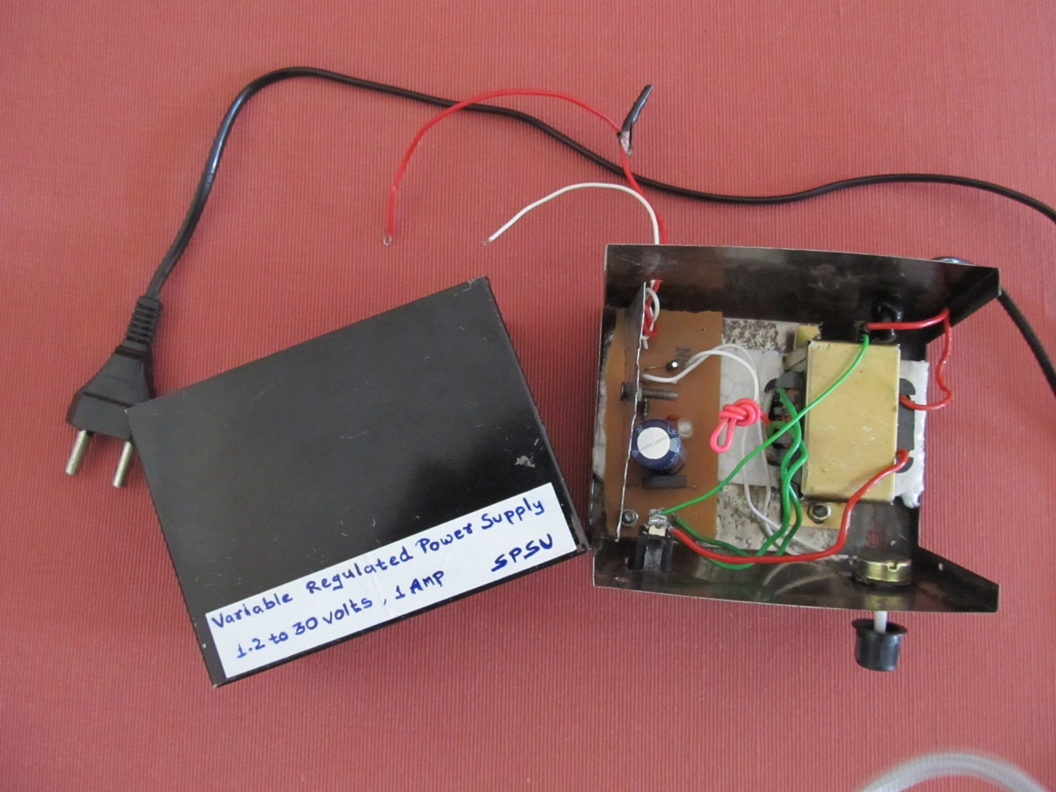

Figure-3: Internal connections for variable regulated power supply.­­­­­